Overview:

* UCSD throw in accuracy was 92.86% | Opponent throw in accuracy was 95.45%
* UCSD had 7 Deep Completed Passes to SJS’s 6
* 63.7% of losses were on the left side | 36.3% of losses were on the right side
  + Quinn had the most losses
* Duel Win Rate (52.89%) Highest this season
  + Second most defensive duels this season at 100 defensive duels
  + Defensive Duel Rate was 64% third highest this season and 15% increase from USD
  + Left side and right side similar on win rate
  + Second least offensive duels this season at 76 offensive duels
  + Offensive Duel Rate was 39.5% third highest this season 7% decrease from USD
  + Left side was 7.6% more accurate than right side
* Forward Pass Accuracy was 63.6%
  + Equal forward passes on left and right
  + Left side is 61.4% accurate | Right side is 70.9% accurate
  + Two attackers Cole and Kai were in top 4 accuracy on team
* Majority of shots and shot assists against UCSD go to UCSD’s right side
* The majority of SJS’s chances came from GK (Less Counter Attacks)

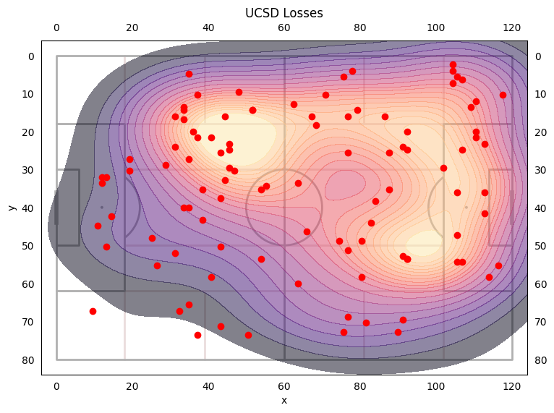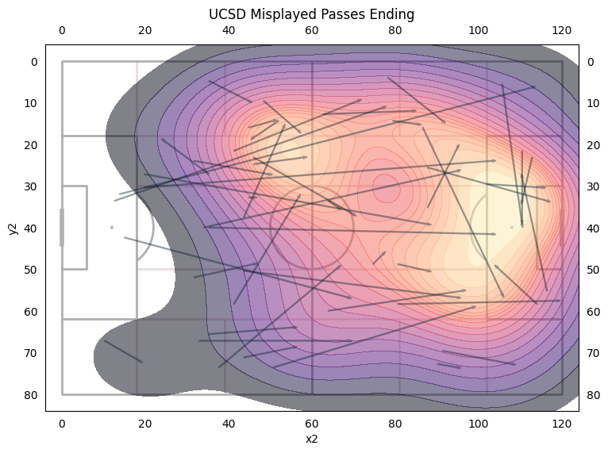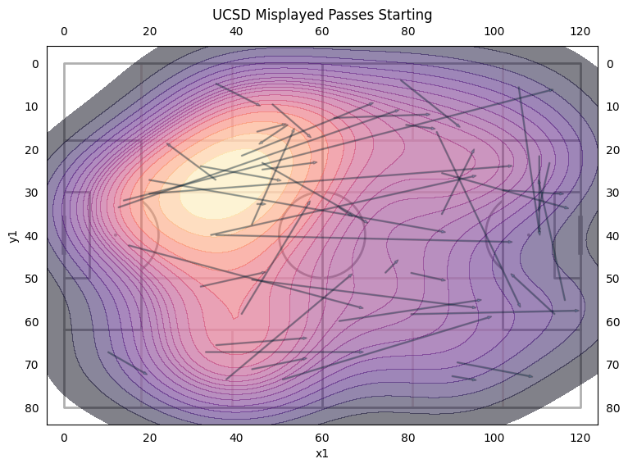

* Least amount of losses this season at 104
* 54.9% of losses are duels 45.1% of losses are misplayed passes
* 63.7% of losses were on the left side
* 36.3% of losses were on the right side
* Players with the most losses: Quinn (13), Max (12), Carter (10), Adam (9), McGee (9)
* Defensive Duel Rate was 64% third highest this season and 15% increase from USD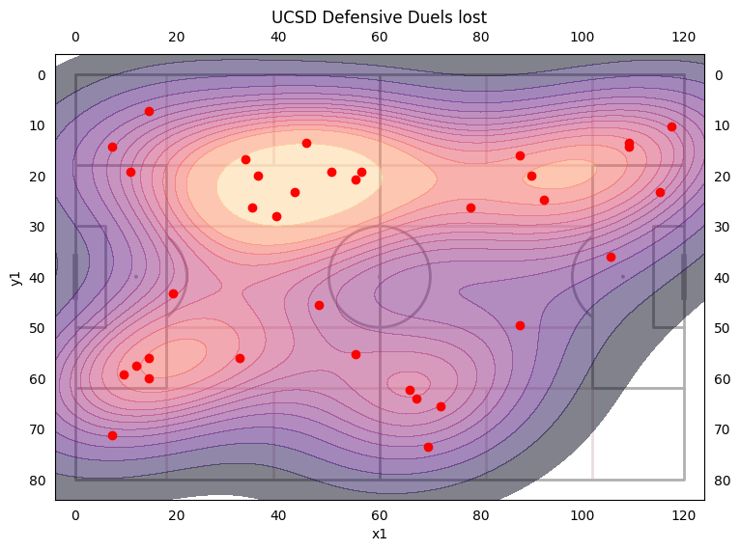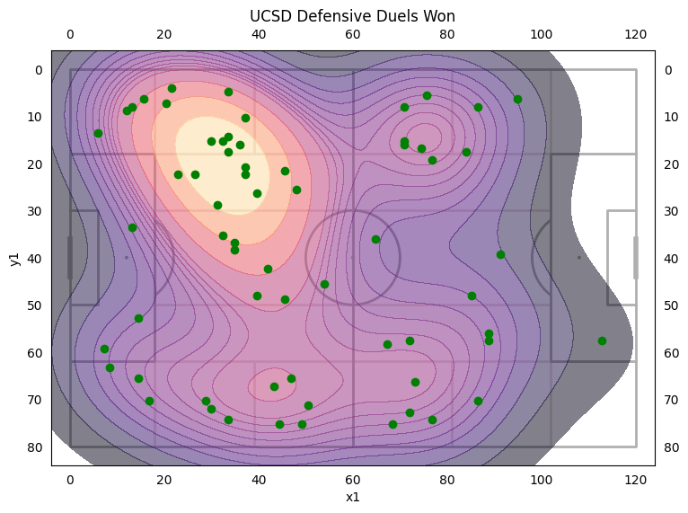
* UCSD won 66.7% of duels in own half
  + Left side won 67.5% of duels | Right side won 65.4% duels
* Highest Winning Players: Cole (83%) 6 Duels, Quinn (78%) 9 Duels, Carter (75%) 8 Duels, James (73%) 11 Duels
* Lowest Winning Players: Brian (25%) 4 Duels, Val (50%) 4 Duels, Max (44%) 9 Duels
* Offensive Duel Rate was 39.5% third highest this season 7% decrease from USD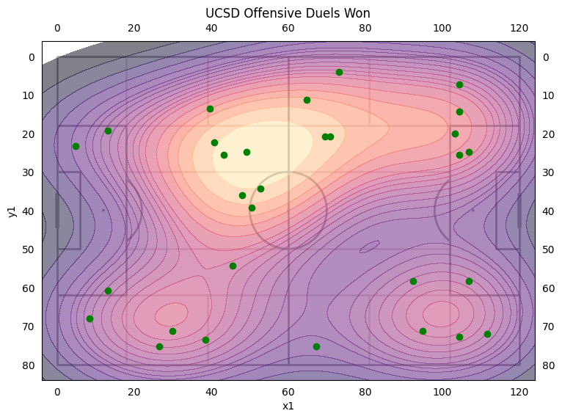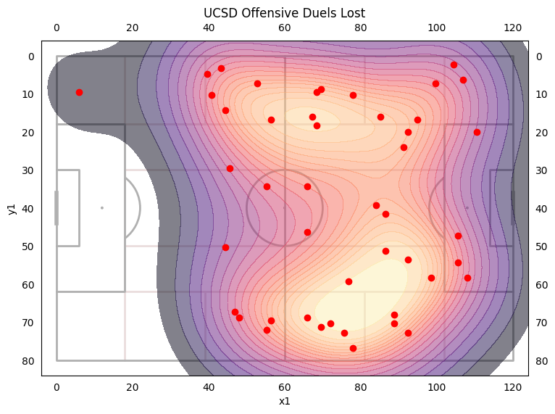
* Left side won 42.9% of their offensive duels
* Right side only won 35.3% of their offensive duels
* Highest Winning Players: James (67%) 6 Duels, Jonah (67%) 3 Duels, Kai (60%) 5 Duels, Quinn (57%) 7 Duels
* Lowest Winning Players: Brian (20%) 5 Duels, **Max (22%) 23 Duels**, Cole (29%) 7 Duels
* UCSD had 7 Deep Completed Passes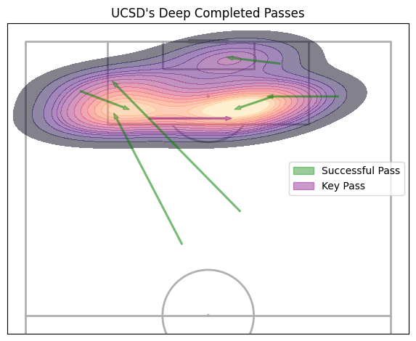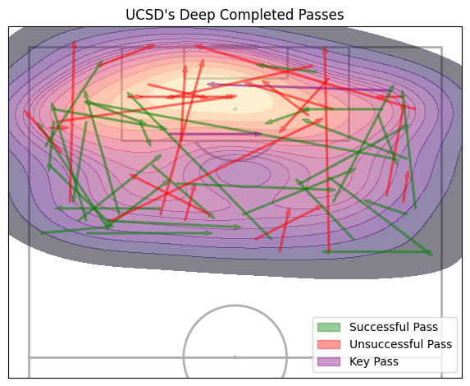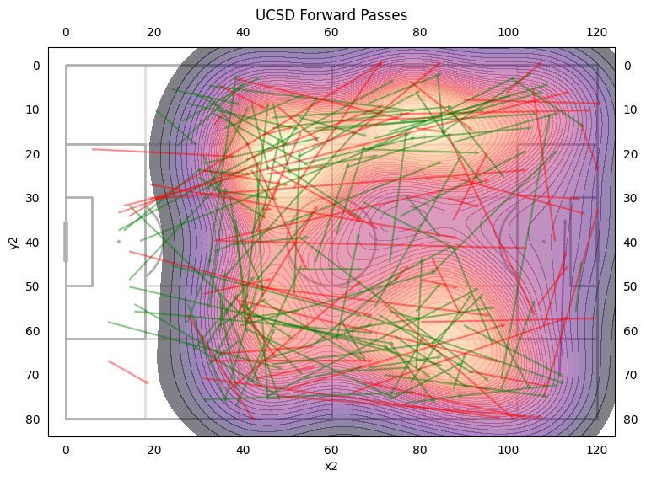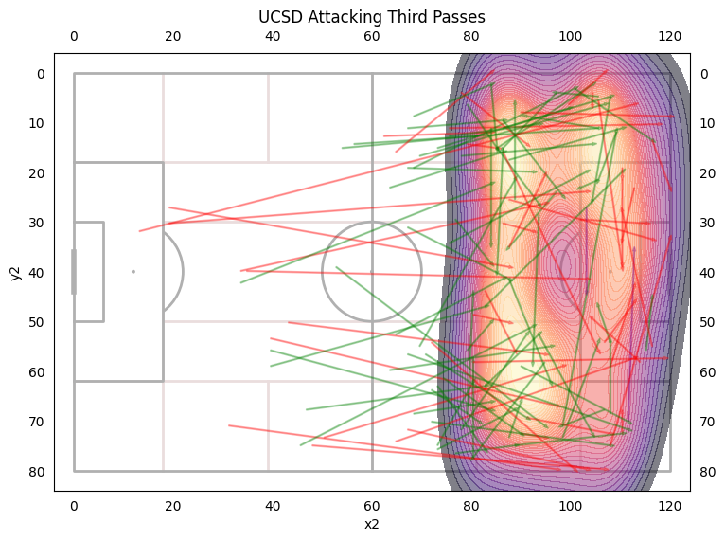
* Forward Passing accuracy of 63.6% a 1% decrease from USD and 2.4% decrease from last year’s average
* 42.9% of forward passes are on the left, 41.9% of forward passes are on the right, 15.1% of forward passes are a switch
* Left side is 61.4% accurate | Right side is 70.9% accurate | Switch is 77.4% accurate

Player Forward Passes

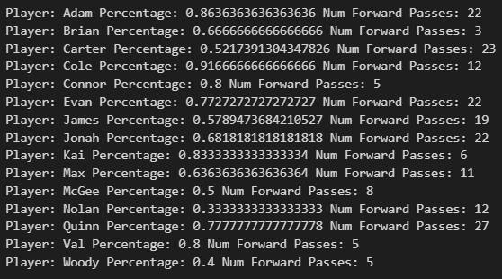

Highest Accuracy: Cole (91.67%), Adam (86.36%), Kai (83.3%), Val (80%)

Lowest Accuracy: Woody (40%), McGee (50%), Carter (52.3%), James (57.89%)

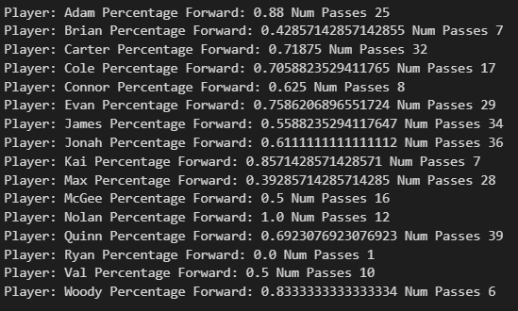

* James only played forward 55.9% of the time and was only 57.9% accurate compared to other defenders and previous games

Chance Origins

* 33% of opponents chances came from passes from GK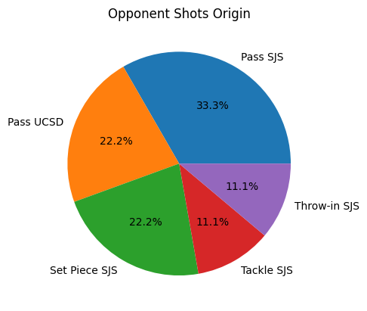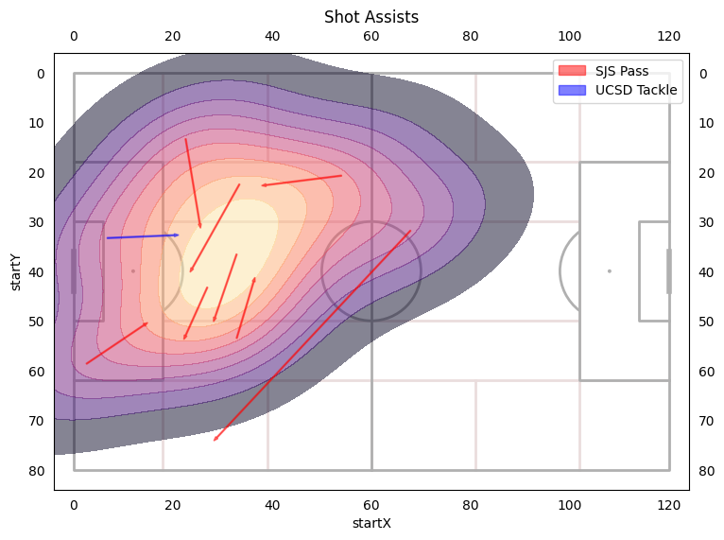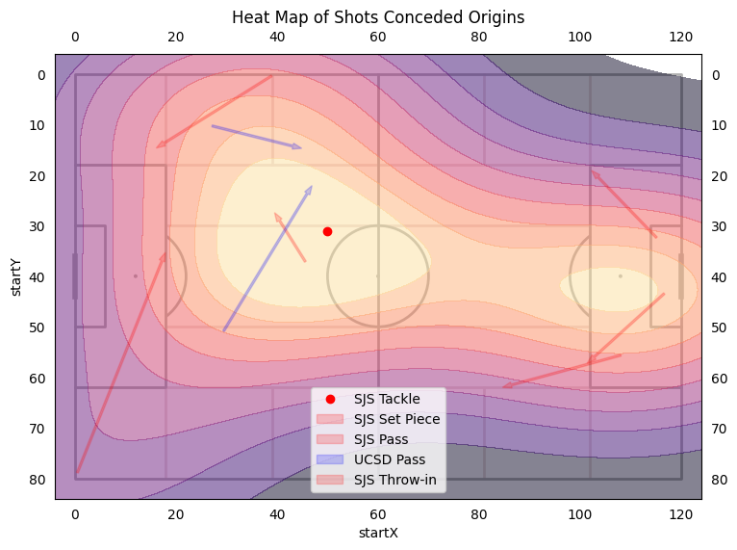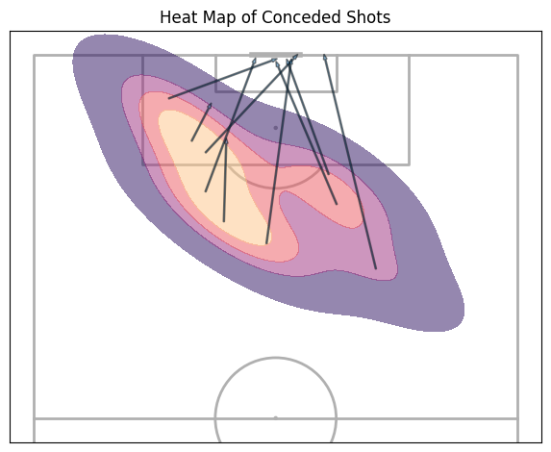
* Majority of shots and shot assists going to UCSD’s right side